Work Manager ver1.3

Ho Chi Minh, November 2016

*A - Added M - Modified D - Deleted
Effective Date | Changed Items | A*  M, D | Change Description | New Version
Nov 25, 16 | First release | A |  | 1.0
Nov 29, 16 | Add diagrams | M |  | 1.1
Dec 5, 16 | Add all description about Windows application | M |  | 1.2
Dec 12, 16 | Modify database. | M |  | 1.3

Database
Database will provide features help people manage data contain:
- Add Teams. (Admin)
- Add Users. (Admin)
- Add Members. (Admin)
- Add Task. (Admin)
- Show data. (User)

  - Overall Description
    - Overview
This database will save all information about Teams, Members, Users andTask.
    - Database diagrams
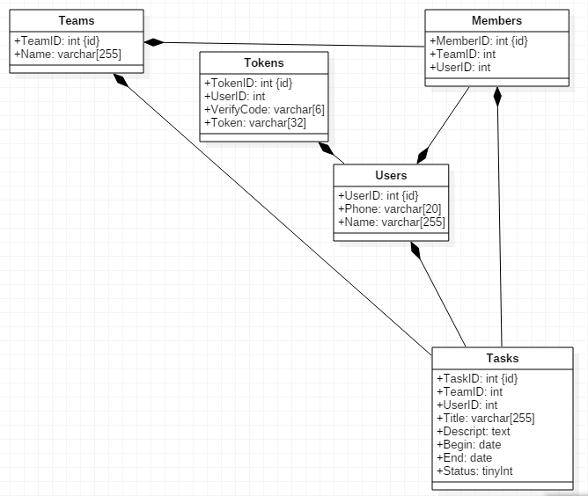

    - Brief Description
Administrator can add information into Teams, Members, Users, Task table.
Tokens table provide one method verify phone number when User want to get Task from server.
    - Initial Step-by-Step Description
  - Features
    - Sofware
      - Teams
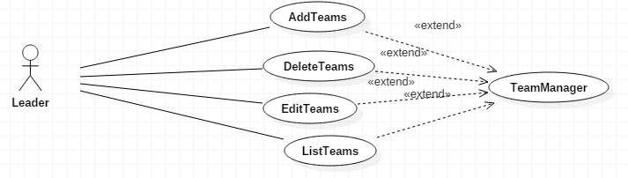
Administrator can add information into Teams table.
        - Use case diagram.
        - Brief Description.
Administrator can add, delete, edit and show list Teams.
      - Members
        - Use case diagram.
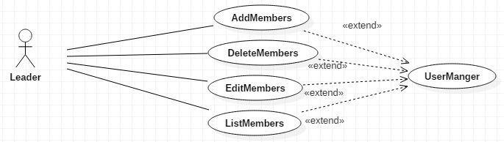
        - Brief Description.
Administrator can add, delete, edit and show list Members.
      - Task
        - Use case diagram.
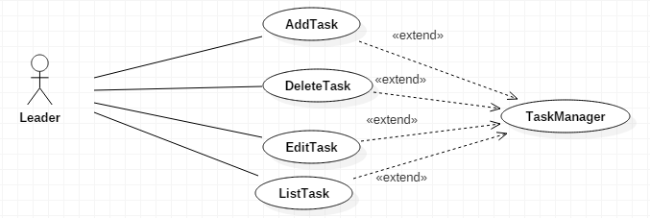

        - Brief Description.
Administrator can add, delete, edit and show list Task.

Manager program
  - Overall Description
    - Overview
This program will setup on manager computer. Manager can Add teams, members, task…
This program save all data upload to server. Manager just work with this program, do not work directly with server.
    - External interfaces
      - Prototype:
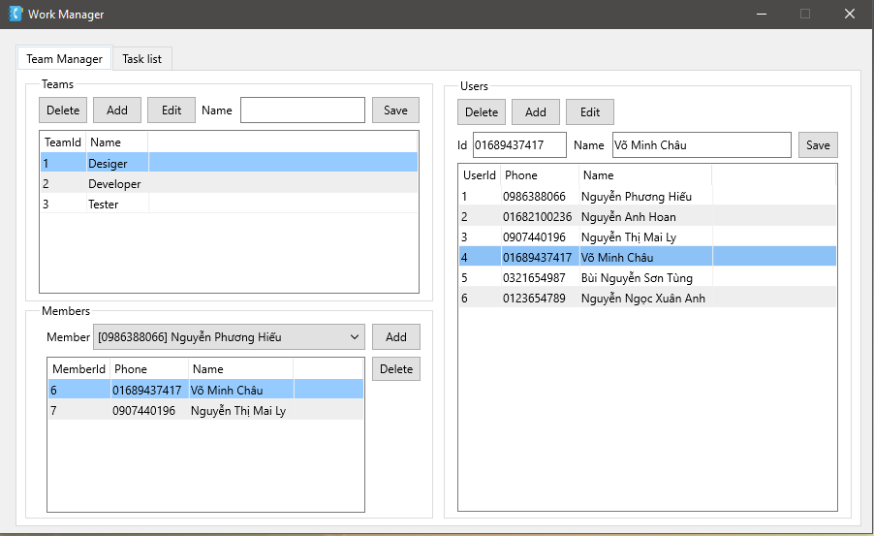

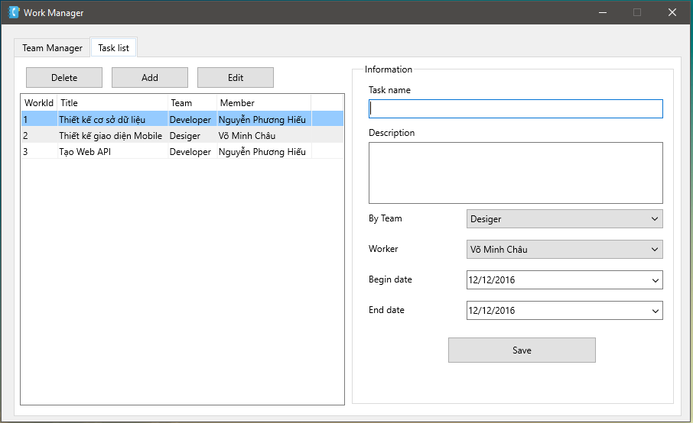

      - Screen description
        - Team Manager
No | Field name | Control type | Data type | Description
1 | Teams | GroupBox |  | This area display all features about Add, Delete, Edit and Save Team by Name.
2 | Members | GroupBox |  | This area display all features about Add, Delete member into Team.
3 | Users | GroupBox |  | This area display all features about  Delete, Edit, Add user by id and name.

No | Area | Field name | Control type | Data type | Description
1 | Teams | Delete | Button |  | This button will delete team.
1 | Teams | Add | Button |  | This button will add team.
1 | Teams | Edit6 | Button |  | This button will edit team.
1 | Teams | Name field | EditBox |  | Default disable.
1 | Teams | Save | Button |  | Save value from Name field.
1 | Teams | DataView | StringGrid |  | Display all teams from server.
2 | Members | Member combo box | Combo Box |  | Display all Members participate in Teams.
2 | Members | Add | Button |  | Add member into Teams.
2 | Members | Delete | Button |  | Delete member from Teams.
2 | Members | DataView | StringGrid |  | Display all member participate in Teams.
3 | Users | Delete | Button |  | Delete selected user out of server.
3 | Users | Add | Button |  | Add member with ID and Name field.
3 | Users | Edit | Button |  | Edit selected user.
3 | Users | ID field | EditBox |  | Enter value when Add new user and display ID user when Edit user.
3 | Users | Name field | EditBox |  | Enter value when Add new user and display username when Edit user.
3 | Users | Save | Button |  | Save value from ID and Name field to server.

        - Task list
No | Field name | Control type | Data type | Description
1 | Information | GroupBox |  | This area display information about Task name, Description, By Team, Worker, Begin date, End date and Save button.
2 | Delete | Button |  | This button will Delete Task.
3 | Add | Button |  | This button will Add Task.
4 | Edit | Button |  | This button will Edit Task.
5 | Data View | DataGridView |  | This area will display all information about Task.

No | Area | Field name | Control type | Data type | Description
1 | Information | Task name | EditBox |  | Display task name from task when Edit button is click.
1 | Information | Description | EditBox |  | Display description about task when Edit button is click.
1 | Information | By Team | Combo Box |  | Display all teams participate with task when Edit button is click.
1 | Information | Worker | Combo Box |  | Display all members participate with task when Edit button is click.
1 | Information | Begin Date | Date |  | Display begin date of task when Edit button is click.
1 | Information | End Date | Date |  | Display deadline of task when Edit button is click.
1 | Information | Save | Button |  | Save value from all above data field into server and display on Dataview.
2 | Left Control | Delete | Button |  | Delete selected task.
2 | Left Control | Add | Button |  | Add task get value from Information GroupBox.
2 | Left Control | Edit | Button |  | When Edit button is click, admin can add new task for each user.
2 | Left Control | DataView | StringGrid |  | Display all task get from server.

  - Workflow
    - Team Manager
      - Teams
When program run Teams data will load from server. It will display on DataView. When admin click any Team, all member participate in team will display on Members groupbox.
        - Delete
Admin can delete selected Teams. When admin click any Teams from Teams List. Button Delete will enable. Admin can click button Delete. It will delete from server.
        - Add
Admin can add Teams. When admin click Add button. Name field will enable. Admin enter any value into Name field.
Then admin click Save button. All value in Name field will save to server.
        - Edit
Admin can edit selected Teams. When admin click any Team from Teams List. Edit button and Name field will enable. Admin can change value in Name field. Then admin click Save button, it will replace current Team name and save to server.
        - Save
When admin add new Team or edit Team, Save button will enable.
      - Members
Member dataview display all member in current selected team. Member combo box diplay member not participated with current Team.
        - Add
When member combo box selected any member and admin click button Add. Member will add to current team.
        - Delete
Admin can delete selected member from current team.
      - User
        - Delete
When admin want to delete any user from server. Choose any user and click Delete button.
        - Add
Admin can add user when click Add button. It will display ID and Name field. Admin must enter value into two field. Then click Save button. It will save to server.
        - Edit
Admin can edit selected user when click Edit button. All information of current user will display into two field are ID and Name field. Admin could change and click Save button and save to server.
        - Save
This field contain ID, Name field and Save button just display when admin click Add or Edit button. All change will add or update to server.
    - Task List
      - Information
        - Task Name
This field contain will display name of Task when admin add to server.
        - Description
Brief or full description talk about mission when user assigned by admin.
        - By Team
It willl display team when user paticipated.
        - Worker
This combo box show all member paticipate in By Team combo box.
        - Begin Date
The day user must do task.
        - End Date
The day task will become deadline.
        - Save button
Save all value in Information group box when admin add or edit Task.
      - Left Control
        - Delete
Admin can delete Task when choose any Task and click Delete button.
        - Add
When admin click Add button, Admin can enter data into Information group box. Then click Save button. New task will add to server and display on Dataview.
        - Edit
Admin can change Task when choose any Task and click Edit button. All information off task will automatic general to Information group box. Admin could change and click Save button.
Current data will replace old data and save to server.
  - Data Format
    - Date/Time Format
Default date format is mm/dd/yy For example: 05/29/14
    - Number Format
Order number has no comma separated For example: 12345

